***NAME : Himanshu Dixit***

***ENROLL NO. : B64178***

***BATCH : B10***

***SOFTWARE DEVELOPMENT FUNDAMENTAL LAB-I(15B17CI171) Assignment Sheet (WEEK-6 PHASE-2)***

***Lab A***

***1.*** *Write a C program to multiply two square matrices.*

***Solution:***

#include<stdio.h>

int main()

{

int a[100][100],b[100][100],c[100][100],n,i,j;

printf("enter the size:");

scanf("%d",&n);

printf("ENTER FIRST MATIRX:\n");

for(i=0;i<n;i++)

{

for(j=0;j<n;j++)

{

scanf("%d",&a[i][j]);

}

}

printf("\n");

printf("ENTER SECOND MATIRX:\n");

for(i=0;i<n;i++)

{

for(j=0;j<n;j++)

{

scanf("%d",&b[i][j]);

}

}

printf("\nMATIRX PRODUCT is:\n");

for(i=0;i<n;i++)

{

for(j=0;j<n;j++)

{

c[i][j]=0;

for(int k=0;k<n;k++)

c[i][j]=c[i][j]+a[i][k]*b[k][j];

}

}

for(i=0;i<n;i++)

{

for(j=0;j<n;j++)

{

printf("%d ",c[i][j]);

}

printf("\n");

}

return 0;

}

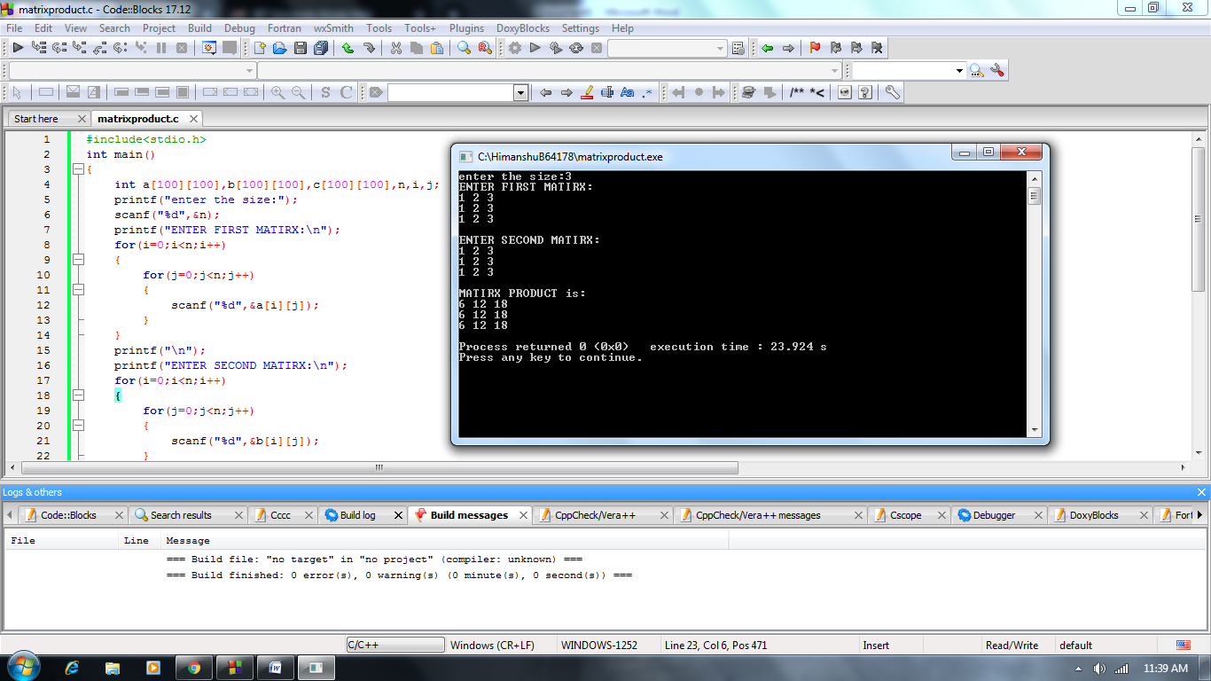

***2.*** *Write a program in C to read a user entered square matrix and then display its diagonal.*

***Solution:***

#include<stdio.h>

int main()

{

int a[100][100],n,i,j;

printf("enter the size:");

scanf("%d",&n);

printf("ENTER MATIRX:\n");

for(i=0;i<n;i++)

{

for(j=0;j<n;j++)

{

scanf("%d",&a[i][j]);

}

}

printf("\nDAIGONAL is:\n");

for(i=0;i<n;i++)

{

for(j=0;j<n;j++)

{

if(i==j)

printf("%d",a[i][j]);

else

printf(" ");

}

printf("\n");

}

return 0;

}

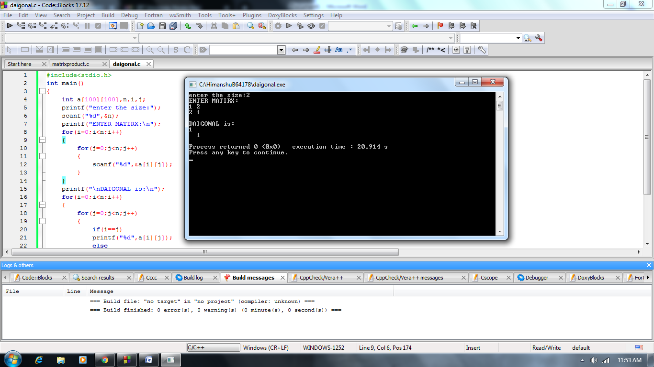

***3.*** *Write a C program to read elements in a matrix and find sum of upper triangular matrix.*

***Solution:***

#include<stdio.h>

void main()

{

int a[100][100],n,sum=0;

scanf("%d",&n);

for(int i=0;i<n;i++)

{

for(int j=0;j<n;j++)

{

scanf("%d",&a[i][j]);

}

}

for(int i=0;i<n;i++)

{

for(int j=0;j<n;j++)

{

if(i<=j)

sum=sum+a[i][j];

}

}

printf("\n%d",sum);

}

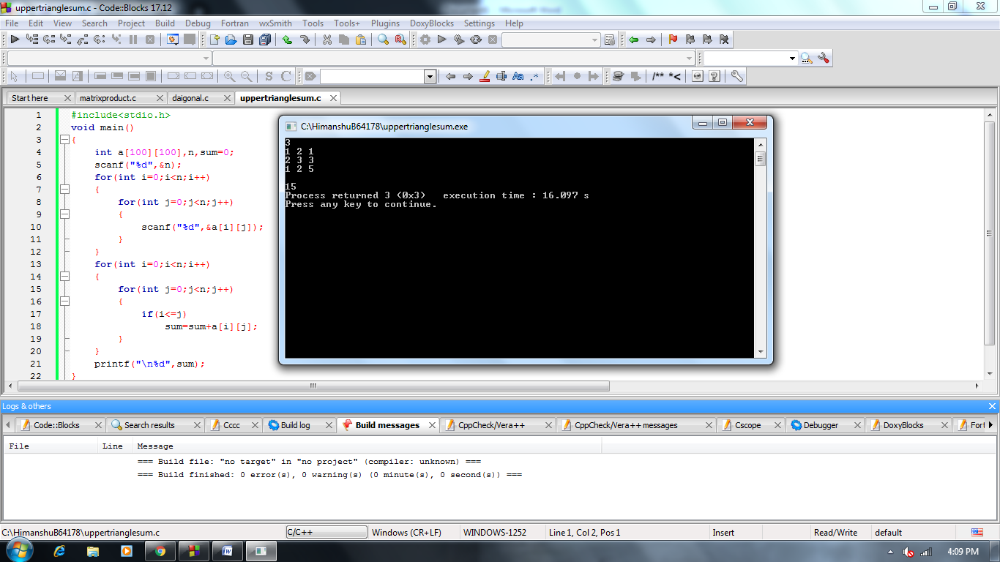

***4.*** *Write a program in C to store and display a 3 dimensional array.*

***Solution:***

#include<stdio.h>

void main()

{

int a[100][100][100],n;

scanf("%d",&n);

for(int i=0;i<n;i++)

{

for(int j=0;j<n;j++)

{

for(int k=0;k<n;k++)

{

scanf("%d",&a[i][j][k]);

}

}

}

for(int i=0;i<n;i++)

{

for(int j=0;j<n;j++)

{

for(int k=0;k<n;k++)

{

printf("%d",a[i][j][k]);

}

printf("\n");

}

printf("\n");

}

}

